SIMATS ENGINEERING
Saveetha Institute of Medical and Technical Sciences
Chennai – 602105
A CAPSTONE PROJECT REPORT
DESIGN AND DEVELOPMENT OF A SMART WASTE MANAGEMENT SYSTEM WITH AUTOMATED TRASH SEGREGATION
Submitted in partial fulfilment for the Course of
CSA1711 – Artificial Intelligence
to the award of the degree of
BACHELOR OF ENGINEERING
Submitted by
T. Charani Kirthi Sri – (192312550)
D. Lokesh – (192372216)
R. Vishwa Teja – (192372109)
Under the Supervision of
Dr. Krishna Kumar
SEPTEMBER 2026

BONAFIDE CERTIFICATE
This is to certify that the Capstone Project entitled “Design and Development of a Smart Waste Management System with Automated Trash Segregation” has been carried out by T. Charani Kirthi Sri (192312550), D. Lokesh (192372216) and R. Vishwa Teja (192372109) under the supervision of Dr. Krishna Kumar and is submitted in partial fulfilment of the requirements for the current semester of the B.E. CSE – AI programme at Saveetha Institute of Medical and Technical Sciences, Chennai.
Course Coordinator ____________________ Course Faculty ____________________
Department of CSE – AI
SIMATS Engineering, SIMATS, Chennai – 602105

DECLARATION
We, T. Charani Kirthi Sri (192312550), D. Lokesh (192372216) and R. Vishwa Teja (192372109), of the CSE – AI programme, Saveetha Institute of Medical and Technical Sciences, Chennai, hereby declare that the Capstone Project Work entitled “Design and Development of a Smart Waste Management System with Automated Trash Segregation” is the result of our bonafide efforts. To the best of our knowledge, the work presented herein is original, accurate, and has been carried out in accordance with principles of engineering ethics and academic integrity. Sources, references, data, software resources and design tools used in the work have been acknowledged where applicable.
Place: Chennai
Date: ____________________
Signature of the Students with Names
T. Charani Kirthi Sri – 192312550
D. Lokesh – 192372216
R. Vishwa Teja – 192372109

INDIVIDUAL CONTRIBUTION STATEMENT
The original project report identifies the three team members but does not assign individual responsibilities. The following allocation is therefore presented as a structured team-work mapping for the Slot C format and should be verified by the students before final submission.
Student / Reg. No. | Specific Responsibilities | Design & Development | Testing & Analysis | Report Contribution | Approx. %
T. Charani Kirthi Sri / 192312550 | Requirement analysis; problem definition; system-object identification | Requirements and OOAD architecture | Design consistency review | Ch. 1–3 sections | 33.3%
D. Lokesh / 192372216 | UML modeling; workflow representation; module decomposition | Use case, class and activity modeling | UML consistency and workflow review | Ch. 2–4 sections | 33.3%
R. Vishwa Teja / 192372109 | Solution documentation; evaluation; future enhancement planning | Sequence/deployment representation and integration | Result interpretation and limitations | Ch. 4–5 sections | 33.4%
TOTAL |  |  |  |  | 100%

ABSTRACT
Improper waste management is a major environmental and operational challenge in rapidly urbanizing areas. Traditional disposal systems depend heavily on manual segregation, which is time-consuming, susceptible to classification errors, and exposes sanitation workers to direct contact with potentially harmful waste. The project addresses this engineering problem through the design of a Smart Waste Management System with Automated Trash Segregation using Object-Oriented Analysis and Design (OOAD) principles. The proposed framework models real-world entities such as users, waste items, smart bins, sensors, classification modules, segregation units, monitoring dashboards and administrators as interacting software objects. The system is organized into modular functions for waste detection, classification, automated segregation, monitoring and administrative control. UML use case, class, sequence, activity and deployment representations are used to describe structural and behavioural aspects of the system. The design supports classification of waste into biodegradable, recyclable and non-recyclable categories using characteristics such as moisture, metal content and material type, while also providing a conceptual mechanism for tracking bin status and segregation statistics. The project scope is primarily analysis, architectural modeling and software-oriented representation rather than full-scale hardware deployment; therefore, the results are interpreted as design-level validation rather than measured field performance. The resulting architecture demonstrates clarity, modularity, maintainability and future extensibility toward IoT connectivity, AI-based computer vision, cloud monitoring and smart-city integration. Overall, the project shows how OOAD can be applied to a sustainability-oriented engineering problem to create a structured foundation for automated waste handling.
Keywords: Smart Waste Management; Automated Segregation; Object-Oriented Analysis and Design; UML; IoT; Sustainable Engineering

TABLE OF CONTENTS
Sl. No. | Title | Page
i | Certificate from the Supervisor | ii
ii | Declaration by the Candidate | iii
iii | Individual Contribution Statement | iv
iv | Abstract | v
v | List of Figures | vi
vi | List of Tables | vii
vii | List of Abbreviations | viii
1 | Chapter 1: Introduction and Engineering Problem | 1
2 | Chapter 2: Literature Review and Existing Solutions | 4
3 | Chapter 3: Engineering Design & Trade-offs, Sustainability, Ethics, Safety, Risk & Security | 7
4 | Chapter 4: Implementation, Testing & Results, Project Management | 13
5 | Chapter 5: Conclusion & Reflection | 18
 | References | 22
 | Appendices | 23

LIST OF FIGURES
Figure No. | Figure Name | Page
1 | System / deployment architecture | 10
2 | Use Case Diagram | 8
3 | Class Diagram | 9
4 | Sequence Diagram | 11
5 | Activity Diagram | 12
6 | Software Output – Waste Upload Interface | 15
7 | Software Output – Monitoring Dashboard | 16

LIST OF TABLES
Table No. | Table Name | Page
1 | Stakeholder / User Requirements | 7
2 | Functional and Non-Functional Requirements | 7
3 | Constraints and Applicable Standards | 8
4 | Design Specifications | 9
5 | Alternative Solutions Evaluation | 10
6 | Trade-off Analysis | 11
7 | Sustainability, Ethics, Safety and Security Evaluation | 12
8 | Risk Register | 13
9 | Tools, Software and Equipment | 14
10 | Test Plan and Verification | 15
11 | Objective Achievement | 17
12 | Project Milestones | 18
13 | Project Roles and Contribution | 19
14 | Cost Summary | 19

LIST OF ABBREVIATIONS / SYMBOLS
Abbreviation / Symbol | Description | Unit
AI | Artificial Intelligence | –
IoT | Internet of Things | –
OOAD | Object-Oriented Analysis and Design | –
UML | Unified Modeling Language | –
UI | User Interface | –
CSE – AI | Computer Science and Engineering – Artificial Intelligence | –
% | Percentage | percent

CHAPTER 1: INTRODUCTION AND ENGINEERING PROBLEM

1.1 Background
Waste management is a critical component of sustainable urban development. Rapid urbanization and population growth increase the volume and complexity of municipal waste, placing pressure on collection, segregation and recycling processes. The source report identifies manual sorting, open dumping and inefficient recycling practices as major limitations because they can contribute to environmental pollution, health risks and loss of recyclable material.
Automation and IoT technologies provide a pathway toward more responsive waste handling. The proposed system therefore treats waste management as an integrated engineering system rather than a single bin function. Waste detection, classification, segregation, monitoring and administrative control are represented as cooperating modules. OOAD is used to translate these real-world functions into objects with defined responsibilities and interactions.

1.2 Need for the Project
The need arises from the interaction of several problems: manual segregation is labour-intensive; incorrect classification contaminates recyclable material; overflowing bins occur when collection is not informed by actual fill status; and municipal authorities have limited operational information for planning collection and resource allocation. These issues affect citizens, sanitation workers, recycling stakeholders and municipal bodies.
The engineering significance is the combination of automation, system modeling and sustainability. A modular design can separate sensing, classification, segregation and monitoring responsibilities, making later hardware or AI integration easier without redesigning the entire conceptual architecture.

1.3 Problem Statement
Design a modular Smart Waste Management System that can conceptually detect and classify deposited waste, route it to an appropriate category, monitor bin status and provide administrative visibility while reducing dependence on manual segregation. The design must remain understandable, maintainable and extensible, despite interacting requirements involving classification accuracy, safety, sustainability, cost, reliability and future hardware integration.

1.4 Project Aim
To design and document a structured, modular and extensible Smart Waste Management System with Automated Trash Segregation using Object-Oriented Analysis and Design principles.

1.5 Project Objectives
• Identify the engineering and operational limitations of manual waste segregation.
• Define stakeholders, functional requirements and system boundaries.
• Model smart bins, sensors, classification, segregation and monitoring as cooperating objects.
• Develop UML representations for system structure and behaviour.
• Evaluate alternative design approaches against performance, cost, safety, sustainability and reliability criteria.
• Validate the design through consistency checks and documented test scenarios, while clearly distinguishing design-level validation from physical prototype measurements.

1.6 Scope
Included: requirement analysis; conceptual waste detection and classification workflow; automated segregation logic; monitoring and administrative control; OOAD architecture; UML use case, class, sequence, activity and deployment representations; software interface evidence included in the original report; and recommendations for IoT, AI and smart-city extension.
Excluded: full-scale physical deployment, quantified field accuracy, long-term environmental measurements, municipal-scale route optimization and hardware performance benchmarking. The original report explicitly frames the core work as system design and architectural modeling rather than full-scale hardware implementation.
Assumptions and boundary conditions include a controlled waste-input workflow, identifiable waste characteristics, functioning sensing/classification logic, defined waste categories and an administrative interface for monitoring. Real-world mixed or hazardous waste conditions would require additional validation before deployment.

1.7 Expected Engineering Outcome
The intended outcome is a documented system architecture and design model that provides a clear pathway from waste input to detection, classification, segregation and monitoring. The outcome is a scalable software/system model and prototype-oriented interface foundation rather than a claim of completed municipal hardware deployment.

CHAPTER 2: LITERATURE REVIEW AND EXISTING SOLUTIONS

2.1 Review Method
The review is based on the technical references and existing-solution discussion contained in the source project report. The report references software engineering and OOAD texts, UML-oriented texts, a World Bank waste-management publication, and an IoT-based smart waste management review. The review was organized around four themes: conventional waste handling, automated/sensor-based segregation, IoT monitoring, and OOAD/UML for complex system modeling.

2.2 Review of Existing Work

2.2.1 Conventional Manual Segregation
The source report describes manual segregation as time-consuming, labour-intensive and vulnerable to human error. It can expose sanitation workers to hazardous material and can mix recyclable waste with organic or other waste. Its main advantage is operational simplicity and low dependence on sophisticated technology, but its limitations become significant as waste volumes and monitoring requirements grow.

2.2.2 Sensor-Based Automated Segregation
The proposed design uses characteristics such as moisture, metal content and material type as conceptual classification inputs. Automation can reduce direct manual handling and provide repeatable decision logic. However, sensor-only classification can be challenged by mixed, contaminated or visually complex items, which is why the source report proposes AI-based recognition as a future enhancement.

2.2.3 IoT-Enabled Monitoring
The source report identifies IoT as a future-ready mechanism for collecting bin fill-level and operational information in real time. Such monitoring can support collection planning and resource optimization. In the current project, IoT is treated as an architectural extension rather than a fully validated field deployment.

2.2.4 OOAD and UML-Based System Modeling
OOAD provides a systematic way to map real-world entities into software objects. The project applies abstraction, encapsulation and modular decomposition to smart bins, sensors, segregation units, monitoring modules and administrators. UML representations make the structural and behavioural relationships explicit, which is especially useful when software logic must interface with future hardware.

2.3 Comparative Analysis
Existing Approach | Advantages | Limitations | Relevance to Proposed Work
Manual segregation | Simple; low technology requirement | Labour-intensive; exposure risk; classification errors | Baseline problem to improve
Fixed-rule / sensor classification | Automatable; repeatable decisions | Limited for complex or contaminated items | Core conceptual classification mechanism
IoT smart-bin monitoring | Real-time status visibility; collection planning | Requires connectivity, sensors and infrastructure | Future integration path
AI / computer-vision classification | Potentially richer recognition of complex waste | Needs datasets, compute and validation | Future accuracy enhancement
OOAD + UML architecture | Modular; maintainable; clear system relationships | Primarily a design method; does not itself validate physical performance | Primary design approach

2.4 Research / Engineering Gap
The source project identifies a gap between promising automation technologies and a clearly structured, extensible system architecture. Sensor-based automation, monitoring and future AI functions need to coexist without producing an unnecessarily coupled design. The project addresses this gap at the system-modeling level by separating responsibilities into modules and representing their interactions explicitly.

2.5 Proposed Contribution
The contribution is a structured OOAD-based architecture for automated waste segregation that combines detection, classification, segregation and monitoring concepts. The architecture is designed to support future IoT, computer vision, cloud and smart-city extensions while keeping the current academic scope focused on analysis and design.

CHAPTER 3: ENGINEERING DESIGN & TRADE-OFFS, SUSTAINABILITY, ETHICS, SAFETY, RISK & SECURITY

3.1 Requirements

Stakeholder / User Requirements
Stakeholder | Requirement
Citizen / User | Dispose of waste through a simple and understandable smart-bin workflow.
Municipal Authority | View bin status and segregation information for operational planning.
Sanitation Worker | Reduce direct exposure to mixed or hazardous waste during manual sorting.
Recycling Stakeholder | Receive better-separated recyclable material streams.
Administrator | Manage system status and access monitoring/reporting functions.
System Designer / Developer | Maintain modularity, clear interfaces and extensibility.

Functional & Non-Functional Requirements
Requirement | Type | Measurable Target
Accept waste input | Functional | Input accepted through defined disposal workflow
Classify waste category | Functional | Return one of the defined categories: biodegradable, recyclable or non-recyclable
Trigger segregation action | Functional | Route classified item to corresponding compartment in the modeled workflow
Monitor bin status | Functional | Expose bin-level status and segregation statistics to administrator
Generate report | Functional | Provide summarized segregation information
Modularity | Non-Functional | Subsystem responsibilities remain separately identifiable in UML
Maintainability | Non-Functional | Changes to one module should not require redesign of unrelated modules
Safety | Non-Functional | Minimize direct human contact with waste during normal operation
Scalability | Non-Functional | Architecture supports later IoT/AI/cloud integration

3.2 Constraints & Applicable Standards
Standard / Code | Requirement | How Applied in This Project
UML notation | Consistent modeling of structure and behaviour | Use case, class, sequence, activity and deployment representations
Engineering ethics / academic integrity | Accurate attribution and honest reporting | Scope and limitations explicitly stated; no fabricated physical performance metrics
Project scope constraint | Design-focused rather than full hardware deployment | IoT and physical mechanisms treated as future/architectural extensions
Resource constraint | Student-scale tools and documentation | UML/modeling and software-interface evidence used instead of municipal-scale infrastructure

3.3 Design Specifications
Parameter | Target / Requirement | Unit | Priority
Waste categories | Biodegradable, recyclable, non-recyclable | categories | High
Classification inputs | Moisture / metal / material characteristics | signals / attributes | High
System architecture | Modular OOAD-based design | architecture | High
Monitoring | Bin status and segregation statistics | status/data | High
Model coverage | Use case, class, sequence, activity and deployment views | diagrams | High
Future extensibility | IoT, AI, cloud and smart-city integration | capability | Medium

3.4 Alternative Solutions & Evaluation
Alternative 1: Manual or rule-based segregation retains a simple operational model but depends heavily on human handling and fixed decision logic.
Alternative 2: Sensor-assisted automated segregation adds automation and monitoring while remaining compatible with the current project scope and future AI enhancement.
Alternative 3: AI/computer-vision-led segregation offers richer recognition potential but requires datasets, model training, compute resources and extensive validation beyond the present project scope.
Criterion | Weight | Alt. 1 Manual/Rule | Alt. 2 Sensor + OOAD | Alt. 3 AI Vision
Performance | 30% | 2/5 | 4/5 | 5/5
Cost | 15% | 4/5 | 4/5 | 2/5
Safety | 20% | 2/5 | 4/5 | 4/5
Sustainability | 15% | 2/5 | 4/5 | 5/5
Reliability / readiness | 20% | 3/5 | 4/5 | 2/5

The scoring is a design-selection matrix rather than measured field data. It reflects the project scope and the relative implementation readiness described in the source report.

3.5 Selected Design & Detailed Design
Alternative 2, the sensor-assisted automated segregation architecture supported by OOAD, is selected because it offers a practical balance between automation, safety, modularity and project feasibility. It improves on manual handling while avoiding the dataset and model-validation requirements of a full AI-vision implementation. The architecture also leaves clear interfaces for future AI and IoT modules.
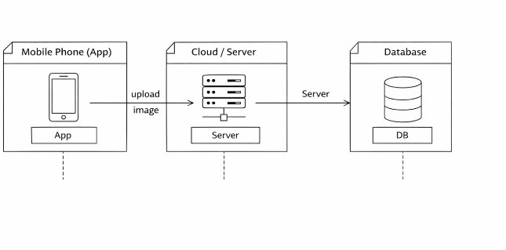
Figure 1. Deployment / system architecture represented in the original project report.

The architecture separates the user-facing application, server-side processing and data storage. The broader system design connects these software elements with waste classification and reporting functions, allowing later integration of sensors and automated mechanisms.

Key engineering logic
Waste is introduced through the smart-bin or software workflow, relevant characteristics are sensed or supplied to the classifier, the classifier determines a category, and the segregation mechanism routes the item. Monitoring data is then made available to the administrative/reporting layer. This sequence separates detection, decision-making, actuation and monitoring responsibilities.

3.6 Trade-off Analysis
Design Decision | Alternative Considered | Benefit | Disadvantage | Final Decision & Justification
Classification mechanism | Manual | Low technology complexity | Labour-intensive; inconsistent | Rejected because it does not address core automation need
Classification mechanism | Sensor-assisted | Good balance of feasibility and automation | Limited for complex waste | Selected for present scope
Classification mechanism | AI vision | Potentially higher recognition capability | Dataset/model/compute burden | Reserved for future enhancement
Monitoring | Local only | Simple | Limited visibility | Use modular monitoring interface with future IoT path
Architecture | Monolithic | Simple initial coding | Poor separation of concerns | Rejected in favour of modular OOAD design

3.7 Sustainability, Ethics, Safety, Risk & Security
Domain | Consideration | Evidence Evaluated | Impact on Final Decision
Sustainability | Improve recycling and reduce landfill dependency | Source report links correct segregation with recycling and reduced contamination | Automated segregation retained; future solar/analytics options identified
Ethics | Responsible automation and honest reporting | Source report emphasizes environmental responsibility and worker safety | No fabricated performance claims; design-level validation clearly stated
Health & Safety | Reduce direct contact with mixed/hazardous waste | Manual handling risk described in source report | Automation and compartmentalization prioritized
Security | Protect monitoring/admin functions and data | System includes administrator and reporting functions | Role-aware architecture and controlled access are recommended for implementation

Risk | Likelihood | Severity | Risk Level | Mitigation | Residual Risk
Misclassification of waste | Medium | High | High | Improve sensing; future AI vision; validate with representative samples | Medium
Sensor failure / unavailable input | Medium | High | High | Health checks, fallback states and maintenance procedures | Medium
Bin overflow | Medium | High | High | Fill-level monitoring and collection alerts in future IoT deployment | Medium
Unauthorized administrative access | Low | High | Medium | Authentication, authorization and audit logging in implementation | Low–Medium
Mechanical segregation fault | Medium | High | High | Interlocks, manual override and maintenance checks | Medium
Poor real-world generalization | Medium | Medium | Medium | Pilot deployment and stakeholder feedback | Medium

CHAPTER 4: IMPLEMENTATION, TESTING & RESULTS, PROJECT MANAGEMENT

4.1 Development Approach & Resources
The project follows a structured OOAD workflow: identify stakeholders and requirements; decompose the system into modules; map real-world entities to objects; model static and dynamic behaviour with UML; review consistency across diagrams; and refine the architecture iteratively. The source report emphasizes requirement analysis, modular decomposition and iterative UML refinement. The implementation evidence available in the original document includes software-interface screens and UML/system diagrams, while physical IoT deployment remains outside the reported scope.

4.2 Hardware / Software / Fabrication Implementation & Modern Tools Used
Tool / Software / Equipment | Purpose | Stage Used
Umbrello / StarUML / Visual Paradigm | UML modeling and documentation | System analysis and design
Software UI / web interface | Waste image upload and user interaction | Prototype / output evidence
Server / application layer | Process image or classification workflow conceptually | System architecture
Database | Store user, classification and report information in the modeled architecture | System architecture
Sensors / microcontroller (proposed) | Physical waste detection and automated actuation | Future prototype stage
Cloud / IoT connectivity (proposed) | Remote monitoring and centralized data | Future deployment stage

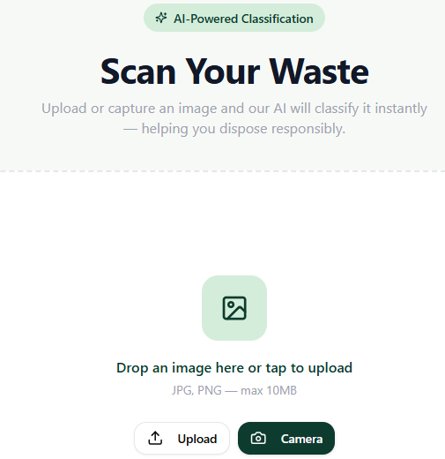
Figure 2. Software output evidence: waste upload / scanning interface from the original report.

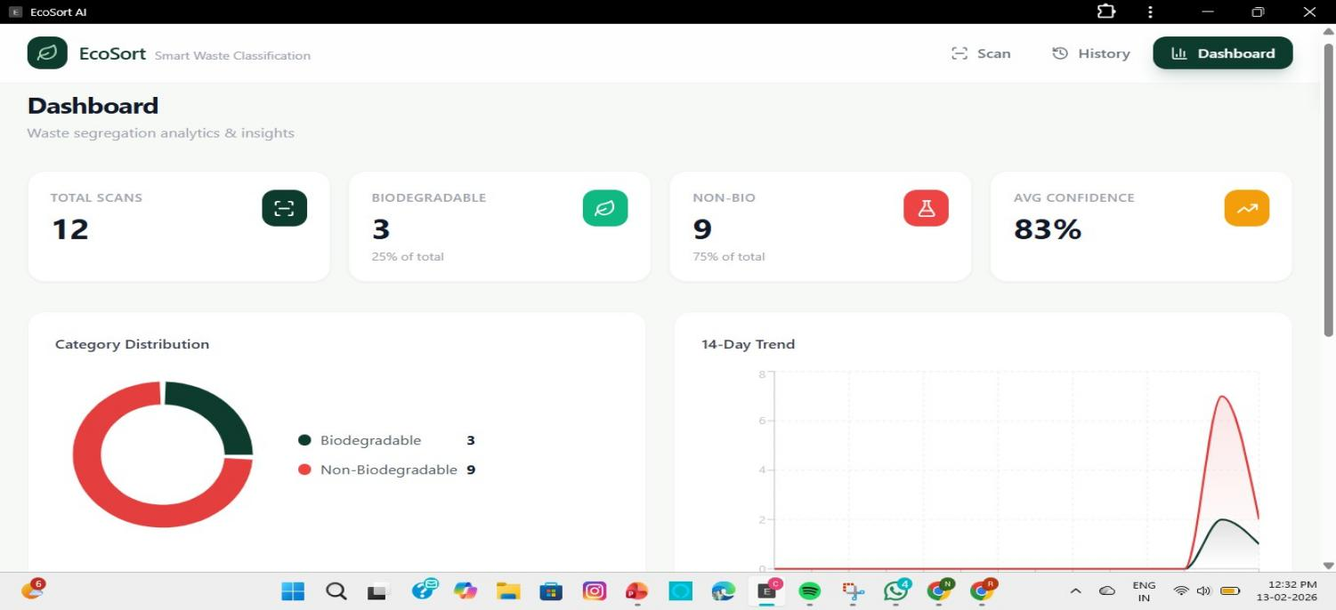
Figure 3. Software output evidence: monitoring dashboard from the original report.

4.3 Test Plan & Verification
Because the source project is primarily an analysis-and-design study, verification focuses on requirement coverage, model consistency and workflow correctness. No physical accuracy or field-performance value is invented here.
Requirement / Specification | Test Method | Acceptance Criterion | Required Value | Achieved Value | Status
User interaction | Trace use cases and UI workflow | All primary user actions represented | Login / upload / view result | Represented in use-case and UI evidence | Pass
Classification workflow | Trace sequence/activity diagrams | Input reaches classification and result state | Complete modeled path | Complete modeled path | Pass
Segregation logic | Inspect activity flow | Decision routes to category output | Category-specific branch | Represented | Pass
Reporting | Inspect class/data model and UI | Report data represented and viewable | Report function present | Represented | Pass
Modularity | Inspect class/deployment structure | Subsystems have defined responsibilities | Separable modules | Represented | Pass
Physical classification accuracy | Field experiment | Measured accuracy against labeled dataset | Not defined in source report | Not measured | Not evaluated

4.4 Results
The project achieved design-level results rather than field-performance results. The UML views demonstrate the intended structural and behavioural organization of the system. The use case representation identifies user and administrator interactions; the class model represents entities such as users, images, classifiers, notifications and reports; the sequence model represents the processing flow; and the activity model shows the decision path from login and image upload through classification and reporting.
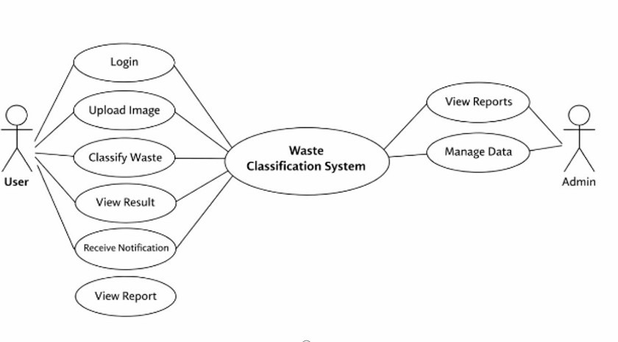
Figure 4. Use Case Diagram from the original project report.

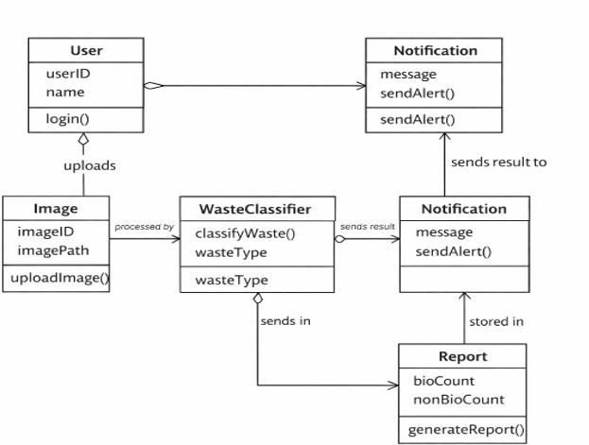
Figure 5. Class Diagram from the original project report.

4.5 Data Analysis & Engineering Judgment
The principal evidence is qualitative and structural. The diagrams are mutually supportive: the use case view defines external interactions, the class view defines responsibilities and relationships, the sequence view defines time-ordered interactions, and the activity view defines control flow. This consistency supports the judgment that the architecture is conceptually coherent.
A key engineering limitation is the absence of a controlled physical test dataset and measured sensor accuracy in the source report. Consequently, claims about classification accuracy, throughput, energy consumption or mechanical reliability cannot be quantified from the available evidence. The correct engineering conclusion is that the design is ready for prototype validation, not that the physical system has already been validated.
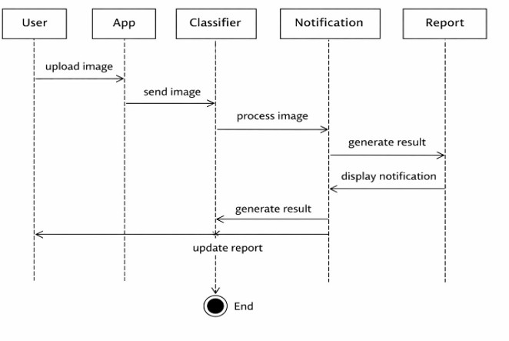
Figure 6. Sequence Diagram from the original project report.

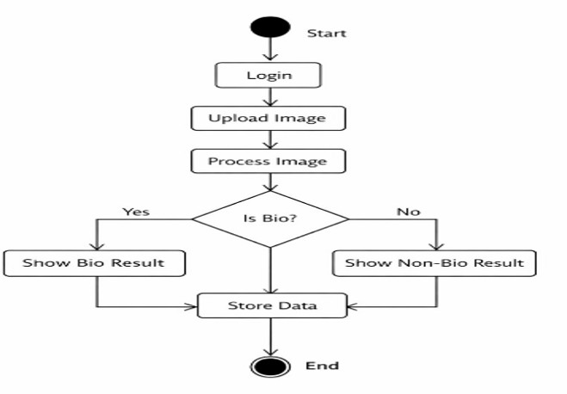
Figure 7. Activity Diagram from the original project report.

4.6 Comparison with Existing Solutions & Achievement of Objectives
Objective | Evidence | Achievement
Identify waste-management limitations | Problem analysis of manual segregation, overflow and contamination | Fully Achieved
Define stakeholders and system scope | Stakeholder and scope analysis | Fully Achieved
Develop modular OOAD architecture | Module decomposition and UML representations | Fully Achieved
Represent system behaviour | Use case, sequence and activity models | Fully Achieved
Provide monitoring/reporting concept | Class model and dashboard evidence | Fully Achieved at design level
Validate physical classification performance | No physical benchmark or dataset reported | Not Evaluated
Prepare path for IoT/AI extension | Future-scope architecture and recommendations | Partially Achieved – architectural level

4.7 Strengths & Limitations
Strengths:
• Clear mapping of real-world waste-management entities to software objects.
• Modular separation of detection, classification, segregation, monitoring and administration.
• Multiple UML views provide complementary structural and behavioural evidence.
• Strong alignment with sustainability and worker-safety goals.
• Architecture supports future IoT, AI, cloud and smart-city integration.
Limitations:
• No reported full-scale physical hardware deployment.
• No measured classification accuracy, precision/recall, throughput or energy results.
• Sensor characteristics and thresholds are conceptual rather than experimentally calibrated.
• Real-world mixed, hazardous or unusual waste requires additional validation.
• Security controls are architectural recommendations rather than demonstrated production controls.

4.8 Project Planning, Roles & Budget
Milestone | Planned Work | Evidence / Outcome
1. Problem definition | Identify waste-management limitations and stakeholders | Problem statement and stakeholder analysis
2. Requirement analysis | Define functional/non-functional needs | Requirement tables
3. OOAD modeling | Identify objects, responsibilities and interactions | UML models
4. Solution refinement | Compare alternatives and trade-offs | Selection matrix and architecture
5. Interface / output evidence | Develop or document software workflow | Upload and dashboard screens
6. Validation | Check model consistency and objectives | Test plan and objective matrix
7. Documentation | Compile final report and references | Capstone report

Student | Assigned Responsibility | Actual Contribution
T. Charani Kirthi Sri | Requirement and system analysis | Team contribution; verify final allocation
D. Lokesh | UML modeling and workflow representation | Team contribution; verify final allocation
R. Vishwa Teja | Evaluation, documentation and future scope | Team contribution; verify final allocation

Item | Estimated Cost | Actual Cost
UML / documentation software | Academic / available resource | Not specified
Software development / interface | Student resource | Not specified
IoT hardware prototype | Future implementation | Not incurred / not specified
Cloud / deployment | Future implementation | Not incurred / not specified

CHAPTER 5: CONCLUSION & REFLECTION

5.1 Conclusion
The Smart Waste Management System with Automated Trash Segregation demonstrates how OOAD can be applied to a real-world sustainability problem. The project converts waste-management activities into a modular architecture containing waste detection, classification, segregation, monitoring and administrative functions. UML representations provide a coherent way to describe users, data, processing and system interactions.
The selected sensor-assisted architecture provides a practical balance between automation and project feasibility. It reduces dependence on manual sorting at the conceptual level and provides a foundation for future IoT and AI integration. At the same time, the project appropriately recognizes that physical accuracy, reliability and large-scale deployment require further prototype and field validation.

5.2 Future Work
• Build a functional prototype using a microcontroller, sensors and an automated segregation mechanism.
• Create a labeled waste-image dataset and evaluate computer-vision models for complex waste categories.
• Integrate IoT connectivity for real-time bin fill-level and system-health monitoring.
• Add cloud storage and a mobile/web administrative application for remote monitoring.
• Use predictive analytics to forecast waste generation and optimize collection schedules.
• Evaluate solar-powered operation for improved energy sustainability.
• Conduct pilot deployment in campuses, residential communities or controlled public environments.
• Collect feedback from municipal authorities, sanitation workers and recycling stakeholders before wider deployment.

5.3 Professional Learning & Individual Reflection

New Knowledge Acquired
• Application of OOAD to an environmental and IoT-oriented problem domain.
• Use of UML to represent both static structure and dynamic behaviour.
• Understanding of modular decomposition and interface responsibilities.
• Awareness of the distinction between design validation and physical performance validation.

Engineering & Professional Skills Developed
• Requirement analysis and stakeholder identification.
• System architecture and trade-off reasoning.
• Technical documentation and diagram consistency.
• Problem-solving, critical thinking and iterative design refinement.
• Team communication and presentation of technical decisions.

Individual Reflection
T. Charani Kirthi Sri: The project strengthened the ability to translate an open-ended environmental problem into structured requirements and system modules. It also reinforced the importance of validating design assumptions before moving to implementation.
D. Lokesh: The project developed practical understanding of UML and the need to keep multiple system views consistent. Iterative refinement improved clarity when representing sensor-driven workflows.
R. Vishwa Teja: The project improved technical documentation, evaluation and future-planning skills. It highlighted how engineering decisions must balance functionality, safety, sustainability and implementation constraints.

5.4 Engineering Reflection
The most important engineering lesson is that a technically attractive feature is not automatically a deployable solution. Automated waste classification can reduce manual effort, but reliability depends on sensing quality, classification logic, mechanical actuation, maintenance, user behaviour and environmental conditions. The project therefore treats the architecture as a foundation for controlled experimentation rather than as a completed municipal product.

REFERENCES
1. Pressman, R. S., Software Engineering: A Practitioner’s Approach, McGraw-Hill Education, 7th Edition.
2. Bruegge, B., and Dutoit, A. H., Object-Oriented Software Engineering Using UML, Patterns, and Java, Pearson Education.
3. Lethbridge, T. C., and Laganière, R., Object-Oriented Software Engineering: Practical Software Development Using UML and Java, McGraw-Hill.
4. Swain, G., Object-Oriented Analysis and Design Through Unified Modeling Language, Laxmi Publications, 2010.
5. Jain, A., Software Engineering with UML, Vision Publications.
6. Stevens, P., and Pooley, R., Using UML: Software Engineering with Objects and Components, Addison-Wesley.
7. Mellor, S. J., and Balcer, M., Executable UML: A Foundation for Model-Driven Architecture, Addison-Wesley.
8. Ghezzi, C., Jazayeri, M., and Mandrioli, D., Fundamentals of Software Engineering, Prentice Hall.
9. World Bank, What a Waste 2.0: A Global Snapshot of Solid Waste Management, World Bank Publications.
10. Kumar, S., et al., “Smart Waste Management Using IoT: A Review,” International Journal of Engineering Research & Technology (IJERT).

APPENDICES

Appendix A – Essential Engineering Logic
The core conceptual flow is: Waste Input → Detection / Sensing → Classification → Category Decision → Automated Segregation → Storage / Bin Status → Monitoring / Reporting. The architecture separates each stage so that sensing or classification technology can be upgraded without changing the entire monitoring layer.

Appendix B – UML Evidence

Appendix Figure B1. Use Case Diagram.


Appendix Figure B2. Class Diagram.


Appendix Figure B3. Sequence Diagram.


Appendix Figure B4. Activity Diagram.


Appendix Figure B5. Deployment Architecture.

Appendix C – Software Evidence

Appendix Figure C1. Waste Upload Interface.


Appendix Figure C2. Monitoring Dashboard.

Appendix D – Submission Note
Before final institutional submission, the team should verify student registration numbers, guide/coordinator designations, exact contribution percentages, dates, signatures, and any physical test values that may have been obtained after the original report. No unreported performance figures have been added to this Slot C conversion.

